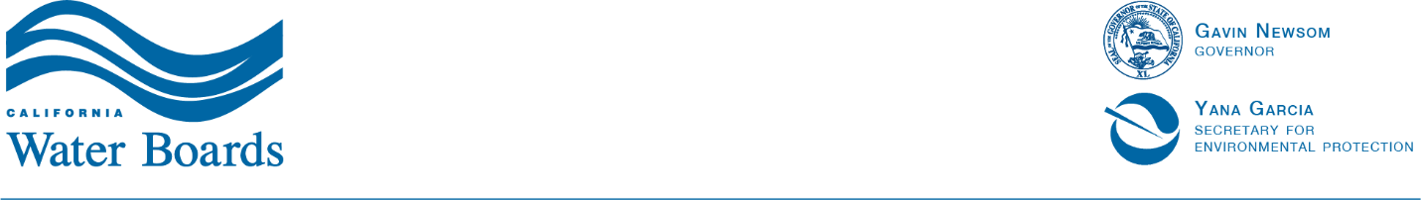

San Francisco Bay Regional Water Quality Control Board

2025 Lake Merritt Water Quality Monitoring Plan
DRAFT
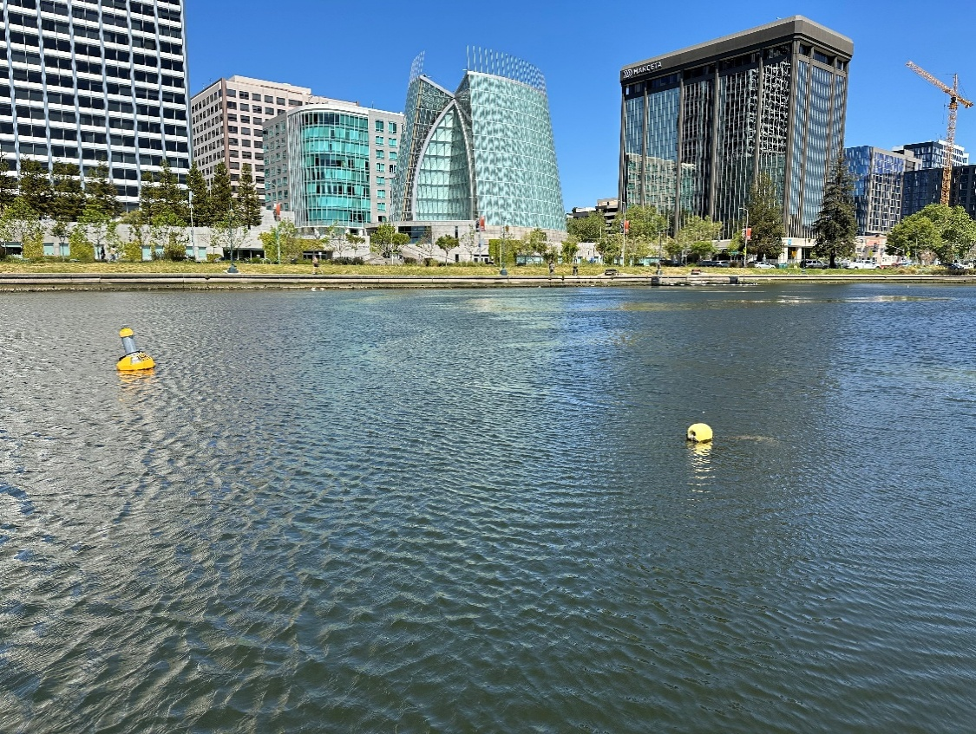

June 2025

Introduction
This document outlines the proposed 2025 Water Quality Monitoring Plan for Lake Merritt. Building upon data collected from 2023 to the present, the plan integrates both ongoing and updated monitoring strategies to assess lake conditions, with a particular focus on dissolved oxygen and nutrient dynamics. The proposed approach includes fixed-station continuous monitoring, nutrient water column grab sampling, and targeted dissolved oxygen monitoring to evaluate the effectiveness of the Hypolimnetic Oxygenation System (HOS). This plan also incorporates initial input from the Water Board-funded Technical Advisory Committee (TAC), based on discussions during our first meeting with the TAC on May 16, 2025. Overall, the monitoring strategy is intended to support data-driven lake management recommendations developed in collaboration with the TAC.

Water Quality Parameters and Monitoring Stations
For 2025, Lake Tech Stations 1, 2, and 3 will remain at their current locations with funding from the City of Oakland (Figure 1). The following water quality parameters will be monitored at each station: dissolved oxygen (DO), temperature, conductivity, chlorophyll-a, and turbidity. Measurements will be taken at two depths at each station: (i) 3 feet below the lake surface and (ii) 1.5 feet above the lakebed to capture both surface and bottom water conditions. The average depth of Lake Merritt is 8-10 feet depending on tidal levels.
From June through October 2024, the Water Board deployed sondes at Stations A and B. For 2025, we propose that the City of Oakland move Station 4 (Rover) to Water Board Station A starting June 2025 (see Figure 1). Water Board Station A is located near the center of the lake and represents one of the deepest areas, making it an important water quality monitoring station.
Additionally, using Water Board funding, we propose installing the Submersible Ultraviolet Nitrate Analyzer (SUNA) sensor at Water Board Station A during the same time period to support continuous nitrate monitoring from June to October 2025. This addition will provide critical data on nutrient dynamics, especially during summer algae bloom events, and help support ongoing dissolved oxygen assessments.
In March 2025, using City of Oakland funding, Lake Tech installed pressure transducers to help assess tide gate operations, including timing of openings and closures. This information is essential for understanding how tide gate activity influences water quality in Lake Merritt. The pressure transducers will continue to operate year-round to provide continuous data on water level fluctuations.
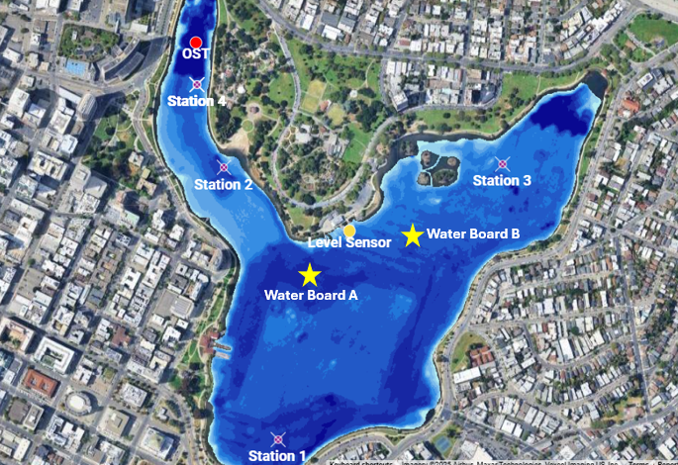
Figure 1. Locations of Stations 1, 2, 3, and 4 (Rover), which serve as the primary continuous water quality monitoring stations in Lake Merritt. Water Board Stations A and B were monitored from June through October 2024.

Water Column Grab Samples
As noted in the previous section, we propose to deploy the SUNA sensor at Water Board Station A (depth: ~8 feet). To validate the continuous nitrate measurements from the SUNA sensor, we propose collecting monthly water column grab samples at Water Board Station A from June through October 2025. These samples will be submitted to BABCOCK Laboratories, Inc. for nitrate and total ammonia analysis, providing a quality assurance check on the SUNA sensor data. In addition to the nitrate grab samples proposed for validating the SUNA sensor, additional nutrient grab sampling may be considered to support a more comprehensive assessment of nutrient dynamics in Lake Merritt.
From June through October 2024, nutrient grab samples were collected at eight locations shown in Figure 2. The samples were analyzed for: nitrate (NO₃⁻) + nitrite (NO₂⁻), total ammonia (NH₃ + NH₄⁺), total Kjeldahl nitrogen (TKN), orthophosphate (PO₄³⁻), and total phosphorus (TP). These analytes provide the basis for calculating total (dissolved) inorganic nitrogen (DIN), total organic nitrogen (TON), total nitrogen (TN), total organic phosphorus, and Redfield Ratios.
For 2025, routine collection of nutrient water column grab samples is not currently recommended as the 2024 results showed little spatial variation within the lake and small changes over the season. However, we are requesting confirmation from the TAC if additional sampling should be conducted. Table 1 outlines a suite of potential water quality parameters that could be sampled.
In addition, sediment nutrient sampling could be conducted, if recommended by the TAC, to improve understanding of nutrient cycling between the sediment and the water column. However, because Lake Merritt is nitrogen-limited, the Water Board did not recommend nutrient sampling, noting that lake management strategies like Phoslock (which targets phosphorus) would likely be ineffective in reducing algal blooms. We request TAC confirmation on whether sediment nutrient sampling is necessary for the 2025 monitoring plan.
Table 1. Potential water quality parameters for grab samples.
Analyte | Preservative | Holding Time | RL | MDL
Total Ammonia | H₂SO⁴ | 28 days | 0.01 mg/L | 0.0049 mg/L
Total Kjeldahl Nitrogen | H₂SO⁴ | 28 days | 0.1 mg/L | 0.093 mg/L
Total Phosphorus | H₂SO⁴ | 28 days | 0.01 mg/L | 0.01 mg/L
Low Level Nitrate + Nitrite | H₂SO⁴ | 28 days | 0.01 mg/L | 0.0038 mg/L
Orthophosphate | None | 48 hours | 0.05 mg/L | 0.016 mg/L
Biochemical Oxygen Demand | None | 48 hours | 1.0 mg/L | 1.0 mg/L
Total Organic Carbon | H₂SO⁴ | 28 days | 0.7 mg/L | 0.13 mg/L
Dissolved Organic Carbon | H₂SO⁴, field filter | 28 days | 0.3 mg/L | 0.19 mg/L
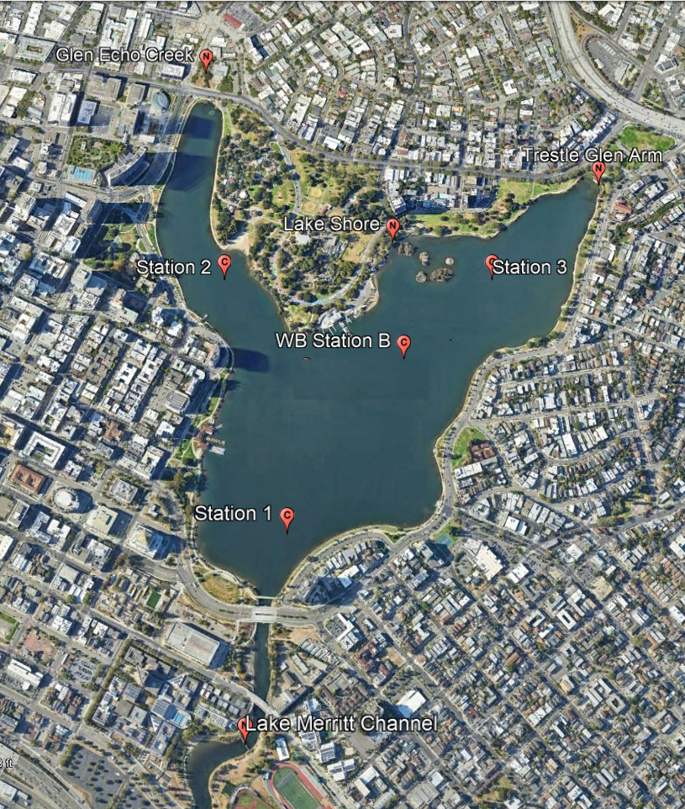
Figure 2. Monthly grab samples were collected from June through October 2024 at the eight locations shown. Samples were analyzed for various nitrogen and phosphorus species.

Hypolimnetic Oxygenation System (HOS) Effectiveness Monitoring
To evaluate the effectiveness of the Hypolimnetic Oxygenation System (HOS) currently deployed in the Glen Echo Arm, we propose a revised monitoring strategy for 2025. Instead of deploying Station 4 (Rover) at the HOS outlet/diffuser, the TAC recommends that boat-based surveys to be conducted to collect DO measurements at multiple distances and depths from the diffuser. This approach will enable assessment of the spatial extent of HOS influence both laterally across the lake and vertically throughout the water column.
We propose conducting these boat-based surveys every other month from June through December 2025 to capture HOS effects across many seasons. This schedule will result in a total of four surveys (i.e., June, August, October, December) that will generate comparative data on system effectiveness. Each survey will include a period when the HOS system is operational as well as a period when the system is turned off. To assess the full influence of the system, we recommend allowing the HOS to run continuously for at least seven days prior to each “on” survey. Conversely, “off” surveys should be conducted within two days of the system being shut down to observe immediate changes in water column conditions. Each survey will measure instantaneous dissolved oxygen using a sonde at the HOS outlet/diffuser, as well as at distances of 10, 25, 50, 100, and 200 feet away in four directions. Measurements should be collected within a 1–2 hour window to minimize variability due to daily DO cycles. Staff will consider the effects of incoming and outgoing tides during these boat-based surveys.

